Name: Miheer Abhyankar

Assignment - Banking System

SQL

Q1 - Retrieve the customer(s) with the highest account balance.

Query –

SELECT c.customer_id, c.first_name, c.last_name, a.account_id, a.balance

FROM Customers c

JOIN Accounts a ON c.customer_id = a.customer_id

WHERE a.balance = (SELECT MAX(balance) FROM Accounts)

Output:

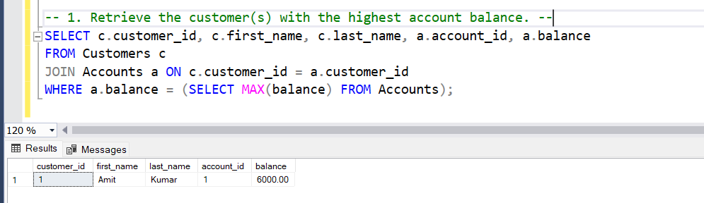

Q2 - Calculate the average account balance for customers who have more than one account.

Query –

SELECT AVG(balance) AS avg_balance

FROM Accounts

WHERE customer_id IN (

SELECT customer_id FROM Accounts

GROUP BY customer_id

HAVING COUNT(account_id) > 1

)

Output:

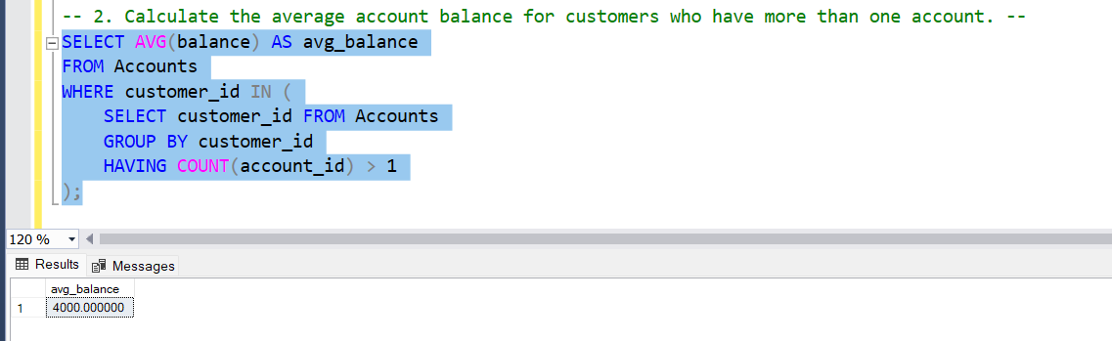

Q3 - Retrieve accounts with transactions whose amounts exceed the average transaction amount.

Query –

SELECT DISTINCT account_id

FROM Transactions

WHERE amount > (SELECT AVG(amount) FROM Transactions)

Output:

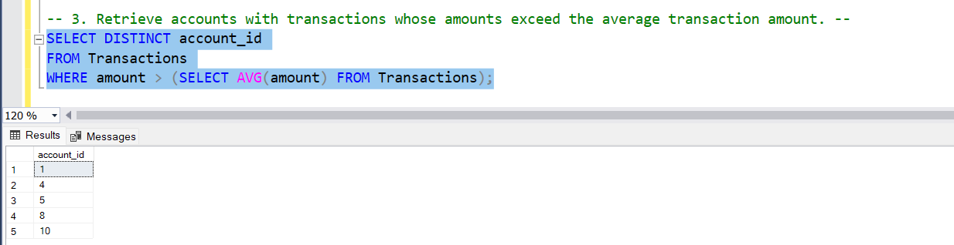

Q4 - Identify customers who have no recorded transactions.

Query –

SELECT c.customer_id, c.first_name, c.last_name

FROM Customers c

WHERE c.customer_id NOT IN (

SELECT DISTINCT a.customer_id

FROM Accounts a

JOIN Transactions t ON a.account_id = t.account_id

)

Output:

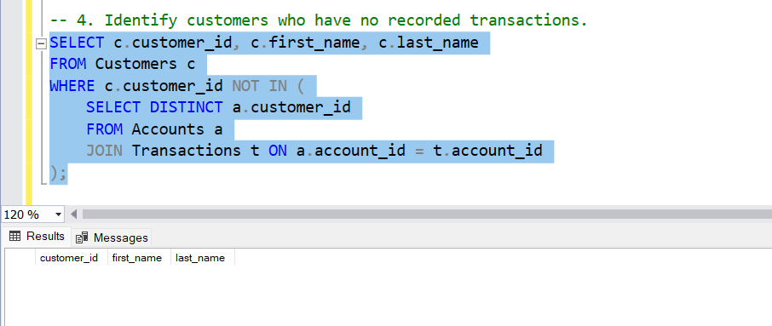

Q5 - Calculate the total balance of accounts with no recorded transactions.

Query –

SELECT account_id, SUM(balance) AS total_balance

FROM Accounts

WHERE account_id NOT IN (SELECT DISTINCT account_id FROM Transactions)

GROUP BY account_id

Output:

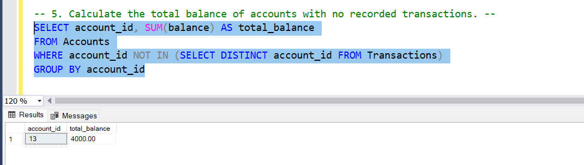

Q6 - Retrieve transactions for accounts with the lowest balance.

Query –

SELECT * FROM Transactions

WHERE account_id IN (

SELECT account_id from Accounts

WHERE balance = (SELECT MIN(balance) FROM Accounts)

)

Output:

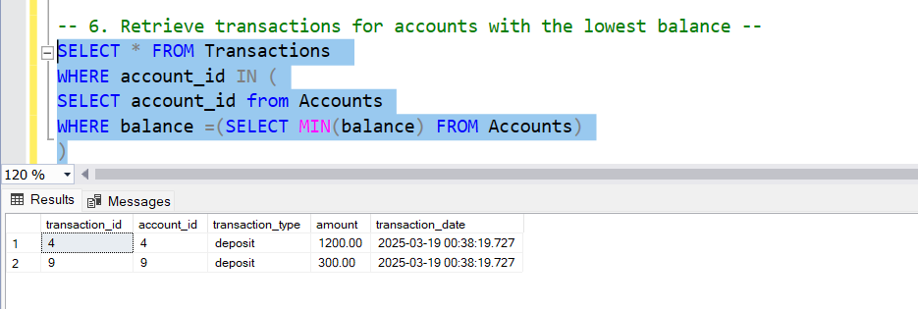

Q7 - Identify customers who have accounts of multiple types.

Query –

SELECT customer_id

FROM Accounts

GROUP BY customer_id

HAVING COUNT(DISTINCT account_type) > 1

Output:

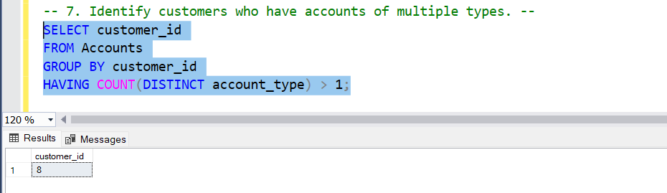

Q8 - Calculate the percentage of each account type out of the total number of accounts.

Query –

SELECT account_type,

COUNT(*) * 100.0 / (SELECT COUNT(*) FROM Accounts) AS percentage

FROM Accounts

GROUP BY account_type

Output:

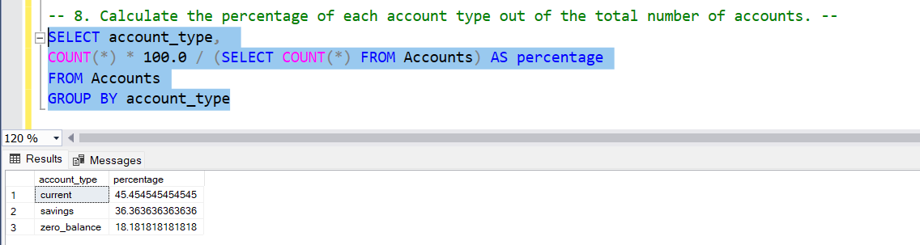

Q9 - Retrieve all transactions for a customer with a given customer_id.

Query –

SELECT t.*

FROM Transactions t

JOIN Accounts a ON t.account_id = a.account_id

WHERE a.customer_id = 7

Output:

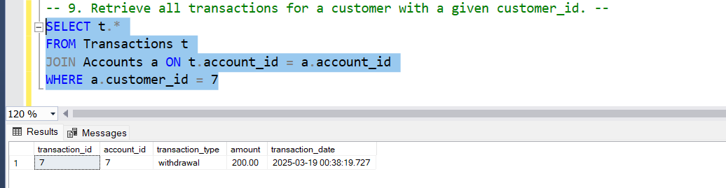

Q10 - Calculate the total balance for each account type, including a subquery within the SELECT clause.

Query –

SELECT account_type,

(SELECT SUM(balance) FROM Accounts a2 WHERE a2.account_type = a1.account_type) AS total_balance

FROM Accounts a1

GROUP BY account_type

Output:

